Assignment 1

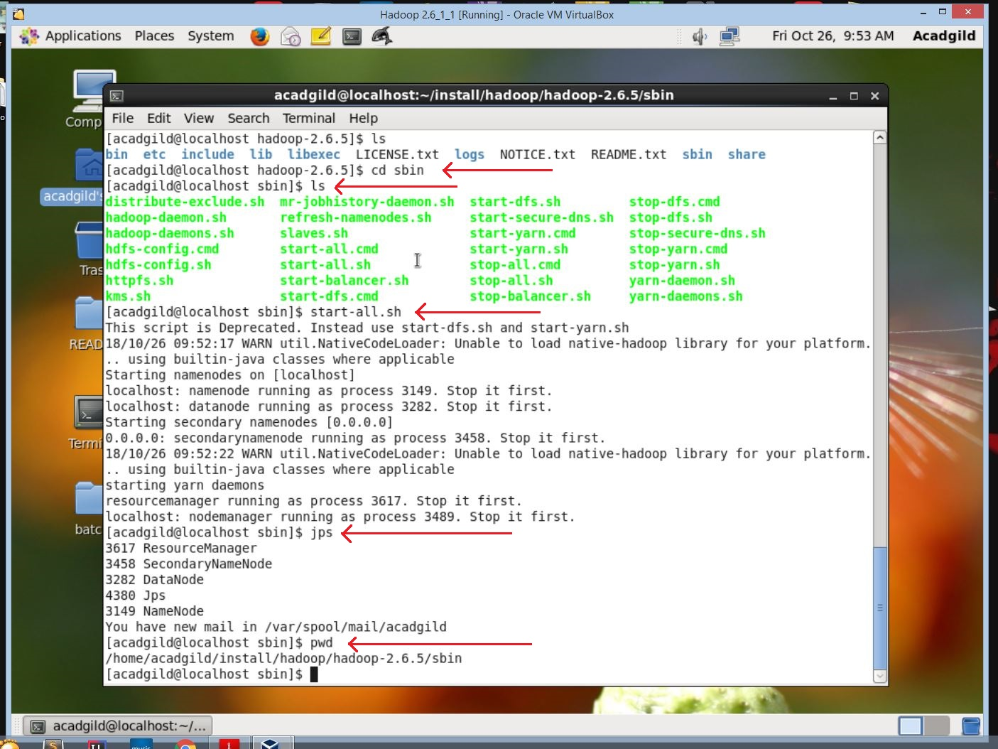

- Opened AcadGild VM and started Hadoop using the command start-all.sh in the folder sbin.

- After starting the Hadoop , I ran jps command to check weather all Hadoop daemons are started successfully or no.

- Pwd is command to check the present working directory.
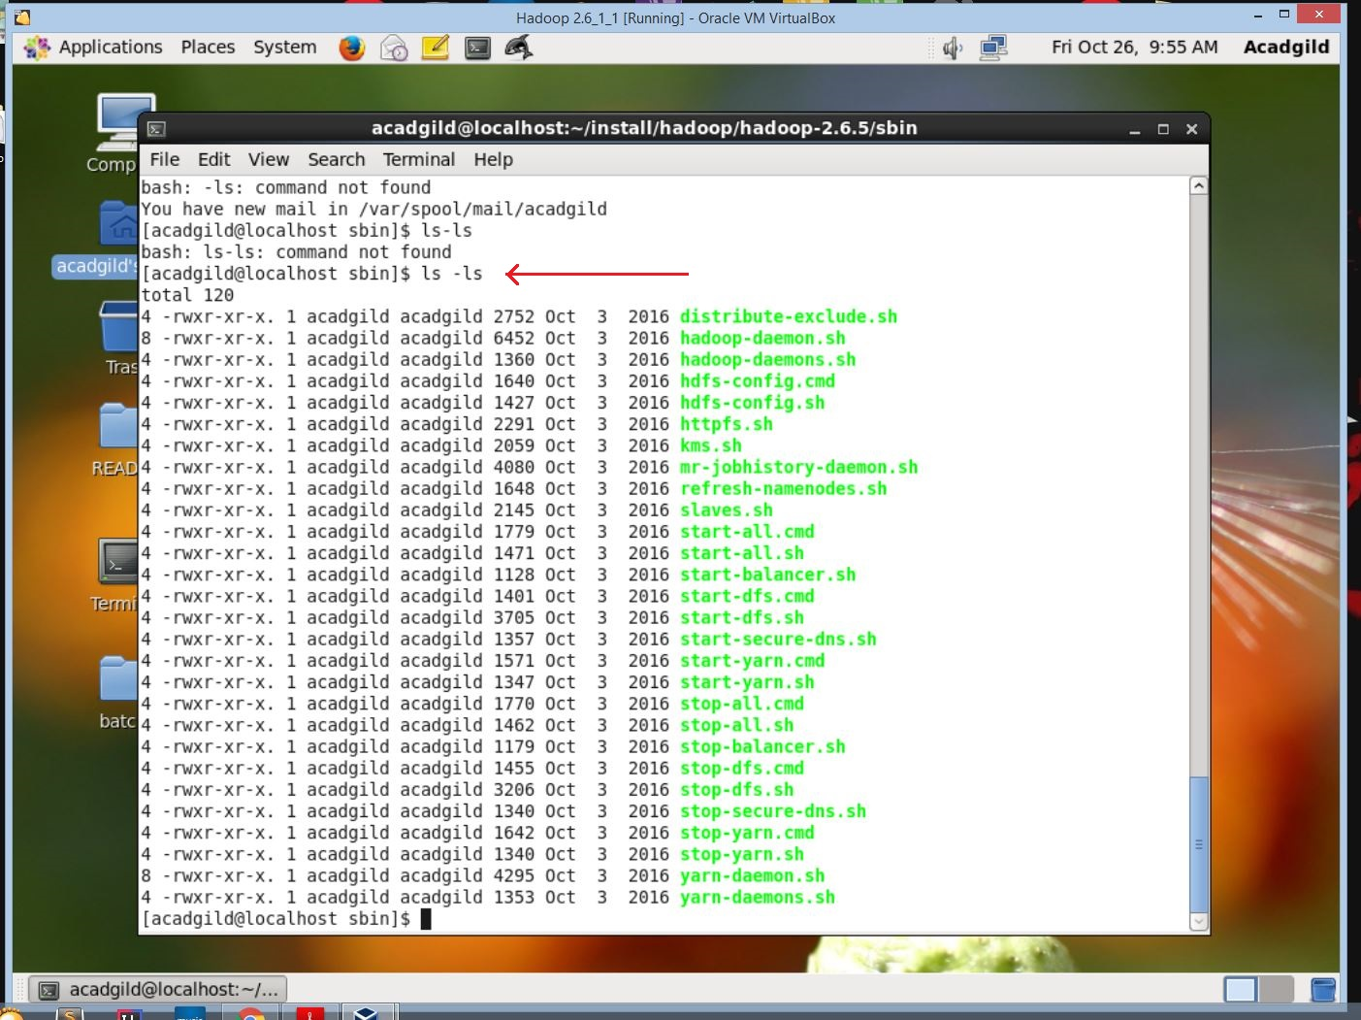
- Ls -ls is command used to list files in long listing format sorted by file sizes

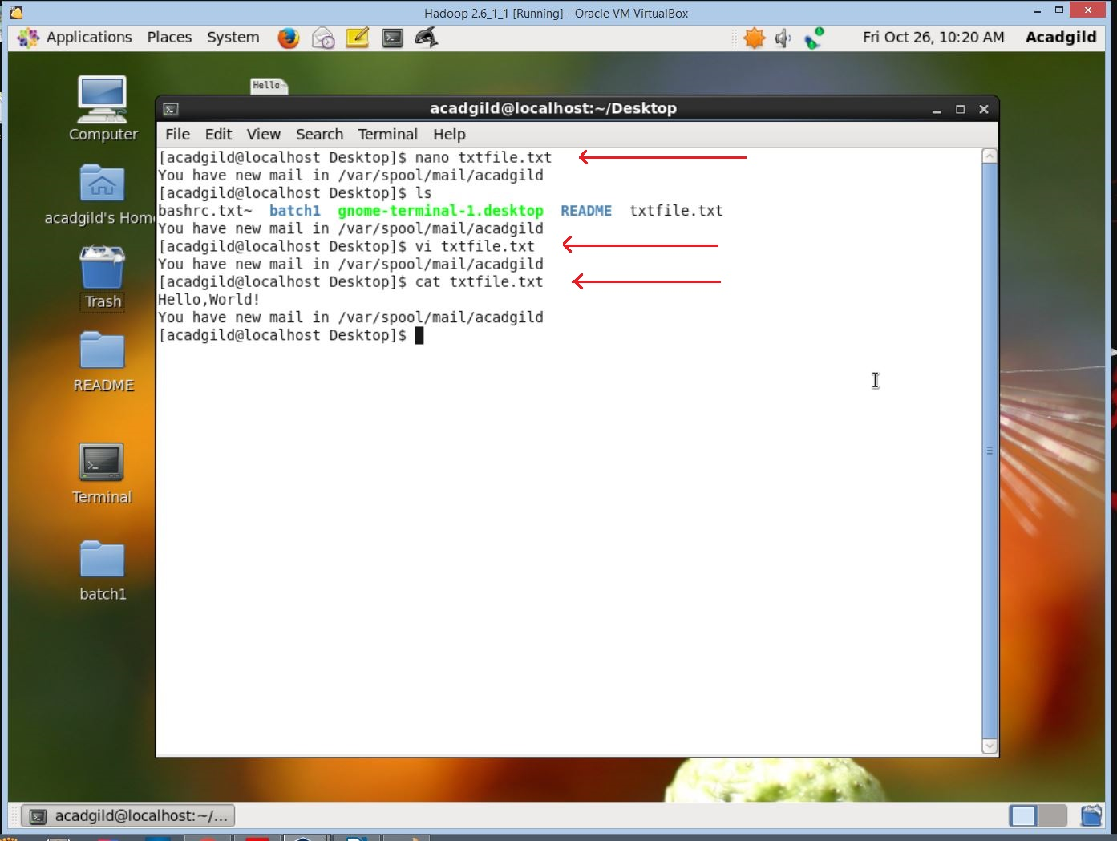

- Nano is a command which we can use to start the nano editor and edit files.
- Vi command is to view the files.
- Cat is a command which concatenates and prints the file.

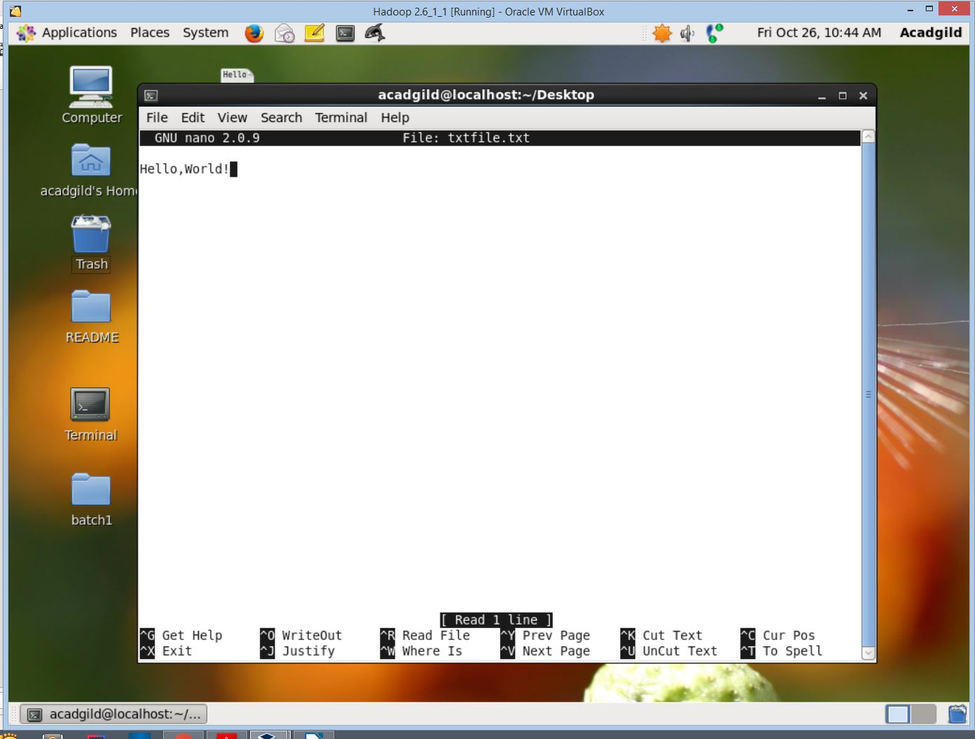

- This is the nano editor.
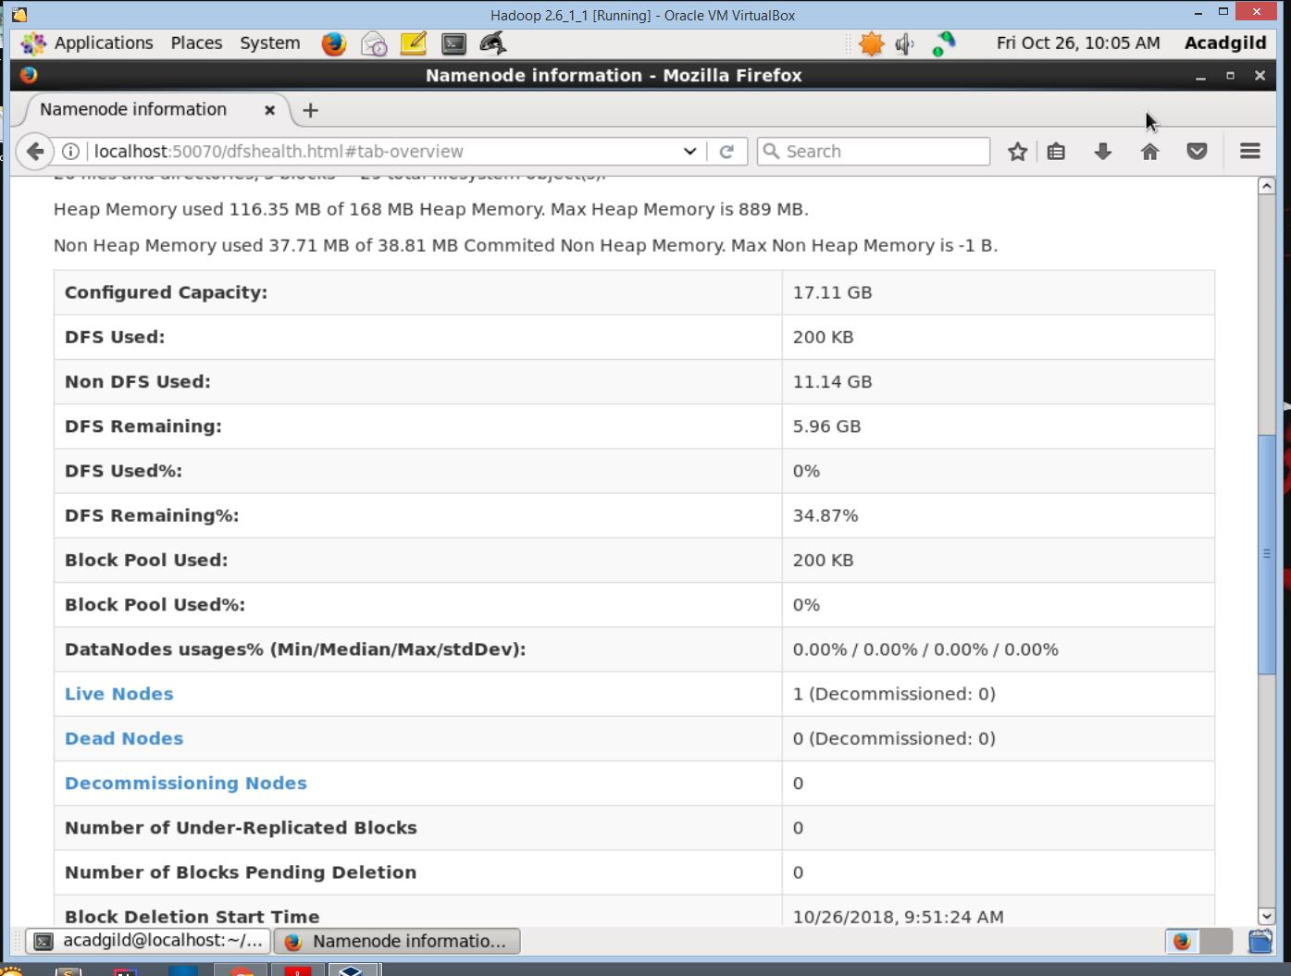
- The HDFS web page where we can check the version of hdfs, starting time of hdfs service, capacity and many important information.

Assignment outcome:

This assignment helped me to get started about hadoop and basics of unix commands and how to use them.

